

Subject

**Assignment**

**Section**

Submitted to faculty: Prof. Nithin George

Date of Submission: 30/11/2023

**Student Details**

|  |  |  |
| --- | --- | --- |
| Roll No. | Name of the Student | Name of the Program |
| AU2120095 | Rishitaa Joshi | B.A. Honours in Psychology |

Monsoon Semester 2023

Unveiling Glasgow's Faces: A Facial Matching Experiment

ABSTRACT

Though its underlying principles and accuracy across a wide range of populations continue to be intensively studied, facial recognition stands as a crucial component of human connection and social functioning. This study attempted to explore the intricacies of face recognition skills among participants in the selected demographic by reproducing and expanding upon the Glasgow Face Matching Task (GFMT) in a regulated environment. The hypothesis for the following research study was participants may demonstrate biases in face matching, showing higher accuracy when matching faces of their own racial or ethnic group compared to faces of other racial or ethnic groups. Participants (N =5) from Ahmedabad University were recruited for the study. Each participant completed a series of trials involving facial matching tasks akin to those presented in the original GFMT. The stimuli included a diverse set of Caucasian and Asian facial images, varying in facial expressions, angles, posture, and difference in lighting. Results revealed that individuals were able to recognize the pair of faces that were Indian faster than the pair of faces that were Caucasian or not Indian, mirroring some aspects of the original GFMT while showcasing nuanced patterns unique to this demographic. Participants exhibited varying degrees of accuracy in facial matching tasks, with factors like familiarity, emotional expression, ethnicity and race influencing recognition performance. Moreover, the replication shed light on potential cultural or demographic-specific nuances in facial recognition abilities, highlighting the need for further exploration in diverse populations. Challenges such as intra-individual variability: expressions, lighting, angles, and occlusions on faces emerged, pointing toward areas for future investigation and potential improvements in face matching methodologies.

INTRODUCTION

Face perception is the cognitive process by which individuals recognize, interpret, and differentiate between faces. It plays a crucial role in everyday social interactions and is often taken for granted. However, for some individuals, such as those with prosopagnosia (face blindness), face perception can be challenging. To understand the mechanisms involved in face perception and to investigate potential impairments, researchers have developed various face matching tasks, such as the Glasgow Face Matching Task. The Glasgow Face Matching Test is one such standardized test that has been widely used in research on face perception. The Glasgow Face Matching Test is a standardized test used to assess the ability of individuals to match unfamiliar faces (Stantic et al., 2021). Participants in the GFMT are presented with pairs of faces and are required to determine whether the faces belong to the same person or different individuals (Stantic et al., 2021).

This test consists of presenting participants with two faces, either belonging to the same person or different people (Stantic et al., 2021). Participants are given an unlimited amount of time to study and analyze the faces before making their decision. In the recreation of the study, some changes were made by the experimenter such that the task measured and collected data to test whether the participants exhibited biases in face matching, resulting in higher accuracy when matching faces of their own racial or ethnic group compared to faces of other racial or ethnic groups

Researchers have been able to examine the correlations between individual variances in performance across several identification tasks involving unfamiliar faces thanks to the Glasgow Face Matching Test and other standardized exams like the Cambridge Face Perception Test. A study on facial recognition and familiarity by Roberta L. Klatzky and Fiona H. Forest studied as to why in episodic memory familiar faces are recognised efficiently than unfamiliar faces. The experimenters conducted several tests to measure memory for faces, including old/new recognition tests, detail recall tests, and orientation recognition tests. The results suggested that the familiarity effect in face recognition may reflect a nonverbal memory representation that is relatively abstract. They also found that most of the dimensions underlying similarity of face judgements are not physical features, like size of nose, but more global and inferential, like attractiveness. This study's findings not only replicate key aspects of the GFMT but also extend our understanding of facial recognition capabilities within a distinct demographic context. Insights gleaned from this replication contribute to the broader conversation surrounding facial recognition mechanisms, emphasizing the importance of accounting for demographic diversity in future research and real-world applications.

Another research study by Ahmed M. Megreya and A. Mike Burton explored the challenges encountered by people while matching unfamiliar faces and strategies that can improve matching accuracy. The study included two experiments that examined the relationship performance on face matching tasks and psychometric variables. The findings of the study suggested the various components of accuracy scores correlate differentially with other measures, and different aspects of visual processing are picking up different components of the face matching task. The paper concludes by discussing the implications of these findings and potential avenues for future research. The paper consisted of two experiments, in the first one, the experimenters found that subjects who were good at matching objects. Across a range of factors, they obtained relatively good scores from the general measures of visual processing onto the processing of unfamiliar faces, although there seem to be some interesting patterns of data, such that different aspects of visual processing are picking up different components of the face matching task. In the second experiment, the experimenters discovered that the familiarization procedure was successful in teaching the subjects the identities. Mean accuracy was increased, even though the procedure was relatively brief.

METHODS

APPARATUS AND STIMULI

The primary device used for conducting the experiment was an Asus laptop with an 15 inch screen. The experiment was conducted through the psychopy software. Participants used a standard keyboard to navigate through the task and provide responses during the experiment. The visual stimuli consisted of pair of faces per image that varied in ethnicity. The faces also had slight variations in the brightness and dullness, facial expressions and face angles. The independent variable in the research study were the pair of faces of varied ethnicities that were presented to the participants. Based on this the reaction time and accuracy in matching faces by the participants was observed and analyzed.

PARTICIPANTS

A total of five individuals took part in the study. The participants were students of Ahmedabad University. The individuals were aged between 20-22 years and all had normal vision. The participants were asked for verbal consent before performing in the experiment and were assured that their personal information would remain confidential.

PROCEDURE

The experiment was designed through the utilization of the psychopy software. In the beginning an instructions routine was added to the experiment which would inform the participants about their task and how to provide responses. Following the main trial was added. This included the images of pair of faces that would be presented to the participant. The individual was required to press the left key if they thought the pair of faces were similar and press the right key if they thought the pair of faces were dissimilar. For providing the response, a keyboard response was added. A textbox was added that displayed a constant text that reminded the keys the participant had to press in order to make the correct response. The conditions file that included the images was added in the loop, with a random loop type as that would present the images containing the pair of faces of different ethnicities in a random manner. An example of the images shown to the participants can be seen from the figure below. The number of reps was kept to just one, as if the participant viewed the images for more than one time, it would pose a risk of priming that could further alter the reaction time of the participants. In the end the participants would see a text that would thank the participants for their contribution in the experiment.

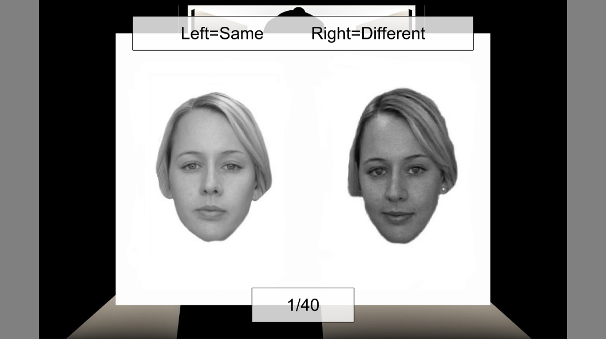

Figure-1

RESULTS

The following research study examined whether during face matching, participants may exhibit biases, matching faces belonging to their own racial or ethnic group more accurately than faces belonging to other racial or ethnic groups. The data of the participants was collected and analyzed through the Psychopy software. After conducting an analysis of the data the average reaction time for individuals in recognizing the Indian pair of faces that were dissimilar was 2.533025 and for Caucasian faces was 2.853284. the average reaction time for recognizing the Indian pair of faces that were similar was 2.787705 and for Caucasian faces was 3.672337. The data revealed that individuals were able to recognize the pair of faces that were Indian faster than the pair of faces that were Caucasian or not Indian. Through the analysis it was also found that individuals also responded more accurately to faces that belonged to their own ethnic group. For further analysis, an analysis of variance was performed through the usage of the JASP software. Through the anova, the p value was found to be less than 0.01, thus the experimenter was able to reject the null hypothesis and accept the alternate hypothesis, the alternate hypothesis being participants will showcase higher accuracy when matching faces of their own racial or ethnic group compared to faces of other racial or ethnic groups.

| **ANOVA – resp.keys** | | | | | | | | | | | |
| --- | --- | --- | --- | --- | --- | --- | --- | --- | --- | --- | --- |
| **Cases** | | **Sum of Squares** | | **df** | | **Mean Square** | | **F** | | **p** | |
| corrAns |  | 7.800 |  | 1 |  | 7.800 |  | 38.570 |  | < .001 |  |
| Residuals |  | 39.838 |  | 197 |  | 0.202 |  |  |  |  |  |
|  | | | | | | | | | | | |
| *Note.*  Type III Sum of Squares | | | | | | | | | | | |

|  |  |  |
| --- | --- | --- |
|  | Indian images | Caucasian images |
| participant 1 | 5.00702 | 5.812885 |
| participant 2 | 2.106172 | 2.64285 |
| participant 3 | 1.243883 | 1.292704 |
| participant 4 | 2.000062 | 2.162548 |
| participant 5 | 2.307985 | 2.355433 |

Table-1 average RT for dissimilar image

|  |  |  |
| --- | --- | --- |
|  | Indian images | Caucasian images |
| participant 1 | 5.228939 | 7.131368 |
| participant 2 | 2.589048 | 3.746738 |
| participant 3 | 1.072361 | 1.386591 |
| partcipant 4 | 2.237132 | 3.208805 |
| participant 5 | 2.811043 | 2.888184 |

Table-2 average RT for similar images

Figure-2

Figure-3

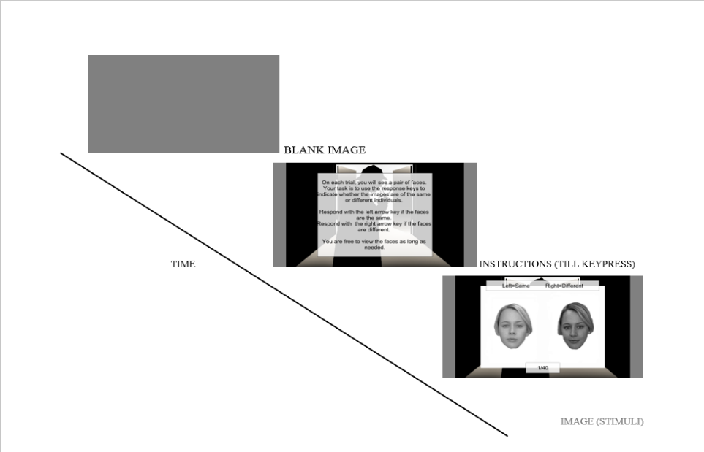

Figure-4

DISCUSSION

The Glasgow Face Matching Task (GFMT) makes a substantial contribution to our understanding of face recognition by clarifying the difficulties people have when matching faces from groups that are distinct from their own. The "other-race effect," in which people typically recognize faces from their own racial or ethnic group more accurately than faces from other groups, is clarified by this exercise. The GFMT assists in identifying potential biases by evaluating the accuracy of matching faces from the participant's own racial or ethnic group versus faces from other groups. It draws attention to whether people are more accurate or biased when it comes to identifying and matching faces based on how similar their racial or ethnic group is. Researchers can investigate how exposure and familiarity affect facial recognition with this task. People's accuracy in recognizing faces may be impacted by their increased exposure to and familiarity with faces from their own racial or ethnic group. The GFMT facilitates the measurement and comprehension of familiarity's function in face matching. It sheds light on the ways in which cultural variables affect one's capacity for facial recognition. Individuals' processing and perception of face features may change due to cultural differences; the GFMT helps to understand how these differences affect recognition accuracy. The GFMT's findings advance our knowledge of face recognition in a variety of demographic contexts. More thorough models of face recognition that take demographic diversity into account can be developed by having a better understanding of the unique difficulties or benefits people have when recognizing faces both inside and outside of their racial or ethnic group.

Even though they are useful, face matching tasks frequently present a number of difficulties that affect the precision and consistency of the outcome. One of those challenges can include intra-individual variability: expressions, lighting, angles, and occlusions on faces vary. It is difficult to reliably match faces, even of the same person, under various circumstances because of these variables. Research shows that people frequently find it more difficult to identify and match faces from racial or ethnic groups that are different from their own because of limited exposure and familiarity, which may introduce biases into the accuracy of face recognition. Face matching tasks can have a high cognitive demand, particularly when people are multitasking or there are other distractions. This may have an impact on matching accuracy by affecting attentional focus. Different people have different levels of expertise when it comes to matching faces. The overall accuracy of the task is affected by the fact that some people are inherently more adept at recognizing faces than others. Having a limited amount of time to view and match faces can increase pressure and possibly result in hurried choices or poor accuracy, particularly when faces are presented quickly or in the middle of other distractions.

In order to ensure more accurate and dependable face matching results, addressing these issues frequently entails improving experimental design, accounting for variables, giving participants proper training, and taking demographic factors into consideration. All things considered, the GFMT is a useful tool for investigating the intricacies of face recognition, particularly when it comes to faces that are members of the participant's racial or ethnic group. It reveals information about cultural influences, biases, familiarity, and the applicability of face recognition algorithms to various demographics. These discoveries have implications for a number of disciplines, such as psychology, neuroscience, and even real-world uses in social interactions and facial recognition software.

REFERENCES

[Stantić, M., Brewer, R., Duchaine, B., Banissy, M. J., Bate, S., Susilo, T., … & Bird, G. (2021). The oxford face matching test: a non-biased test of the full range of individual differences in face perception.. https://doi.org/10.31234/osf.io/afsr6](Stantić,%20M.,%20Brewer,%20R.,%20Duchaine,%20B.,%20Banissy,%20M.%20J.,%20Bate,%20S.,%20Susilo,%20T.,%20…%20&%20Bird,%20G.%20(2021).%20The%20oxford%20face%20matching%20test:%20a%20non-biased%20test%20of%20the%20full%20range%20of%20individual%20differences%20in%20face%20perception..%20https://doi.org/10.31234/osf.io/afsr6)

[Burton, A. M., White, D., & McNeill, A. (2010). The glasgow face matching test. *Behavior Research Methods*, *42*(1), 286–291. https://doi.org/10.3758/BRM.42.1.286](Burton,%20A.%20M.,%20White,%20D.,%20&%20McNeill,%20A.%20(2010).%20The%20glasgow%20face%20matching%20test.%20Behavior%20Research%20Methods,%2042(1),%20286–291.%20https://doi.org/10.3758/BRM.42.1.286)

[Recognition of briefly presented familiar and unfamiliar faces. (2009). *Psihologija*, *42*(1), 47–66. https://www.ceeol.com/search/article-detail?id=694117](%20%20%20%20%20%20%20%20%20%20Recognition%20of%20briefly%20presented%20familiar%20and%20unfamiliar%20faces.%20(2009).%20Psihologija,%2042(1),%2047–66.%20https:/www.ceeol.com/search/article-detail?id=694117)

[The Glasgow Face Matching Test](https://acrobat.adobe.com/id/urn:aaid:sc:AP:aa0346a2-9d50-4240-b0f4-e3f8e70ecd0f)

[McNeill, Allan. “The Glasgow Face Matching Test.” *Behavior Research Methods*. *www.academia.edu*, https://www.academia.edu/14976323/The_Glasgow_Face_Matching_Test. Accessed 30 Nov. 2023.](McNeill,%20Allan.%20“The%20Glasgow%20Face%20Matching%20Test.”%20Behavior%20Research%20Methods.%20www.academia.edu,%20https:/www.academia.edu/14976323/The_Glasgow_Face_Matching_Test.%20Accessed%2030%20Nov.%202023.)

|  |  |  |
| --- | --- | --- |
| **Sr. No.** | **Title** | **Particulars** |
| 1 | Is approval by other Ethics Committee required? If ‘Yes’ mention the details. | NO |
| 2 | Type of review requested | **Exempted Review**/ Expedited Review/ Full   Committee Review |
| 3 | Justify why a human study is needed to answer the research questions. | Because the study measured and collected data to test whether the participants exhibited biases in face matching, resulting in higher accuracy when matching faces of their own racial or ethnic group compared to faces of other racial or ethnic groups. |
| 4 | Participant recruitment process and eligibility criteria | Participants aged between 20-25 years were selected for the study. The participants were selected from the university |
| 5 | Number of participants required with necessary justification. | 5 participants took part in the experiment. The number of participants was recommended by the professor of the course |
| 6 | Justify inclusion and exclusion of vulnerable population | Including vulnerable populations ensures a more comprehensive understanding of human behavior and cognition. Some studies may require additional resources or support to accommodate the specific needs of vulnerable populations. Exclusion might occur due to limitations in providing necessary accommodations. |
| 7 | Procedure for seeking and obtaining informed consent with a sample of the patient/participant information sheet and informed consent forms in English and local languages. [AV recording if needed]  Informed consent for stored samples | Participants were verbally asked for consent and no form was required to be filled by them. |
| 8 | Plan for statistical analysis of the study | a single factor anova and one paired t-test was done for the analysis |
| 7 | Explain the plans to maintain confidentiality of  records / data of the study participants | While recording the data of the participants, their names were not stored instead the participants were given numbers to maintain anonymity |
| 8 | Explain all anticipated risk (adverse events, discomfort) or injury that may be caused to the participant | as the experiment was conducted on a laptop and was relatively brief, there were no anticipated risks or injury that could be caused to the participant |
| 9 | Efforts taken to minimize the risk or injury | It was made sure that the participant were comfortable before they performed the experiment |
| 10 | Whether 'wage compensation' for the research subjects will be provided? [Compensation/ Reimbursement of incidental expenses and management of research related injury/illness] | NA |
| 11 | Expected 'benefits' to volunteer / community | Volunteers contribute directly to scientific knowledge and advancements by participating in Psychopy experiments. Participants often learn about the research process, gaining insights into the scientific methodology, experimental design, and the specific area under investigation. |
| 12 | Account of storage and maintenance of all the human material or data obtained from the study | The data of the participants was collected by psychopy software and was stored in excel sheets |
| 13 | Explain the plans of publication of results (positive or negative) while maintaining confidentiality of personal information/identity | The experiment will be posted on github repository along with the raw data of the participants. The names of the participants was not saved in the excel sheets |
| 14 | Specific ethical issues, as identified by the investigating team | None |
| 15 | List of documents enclosed for ethical review | None |